**PIZZA SALES SQL QUERIES**

**A. KPI’s**

**1. Total Revenue:**

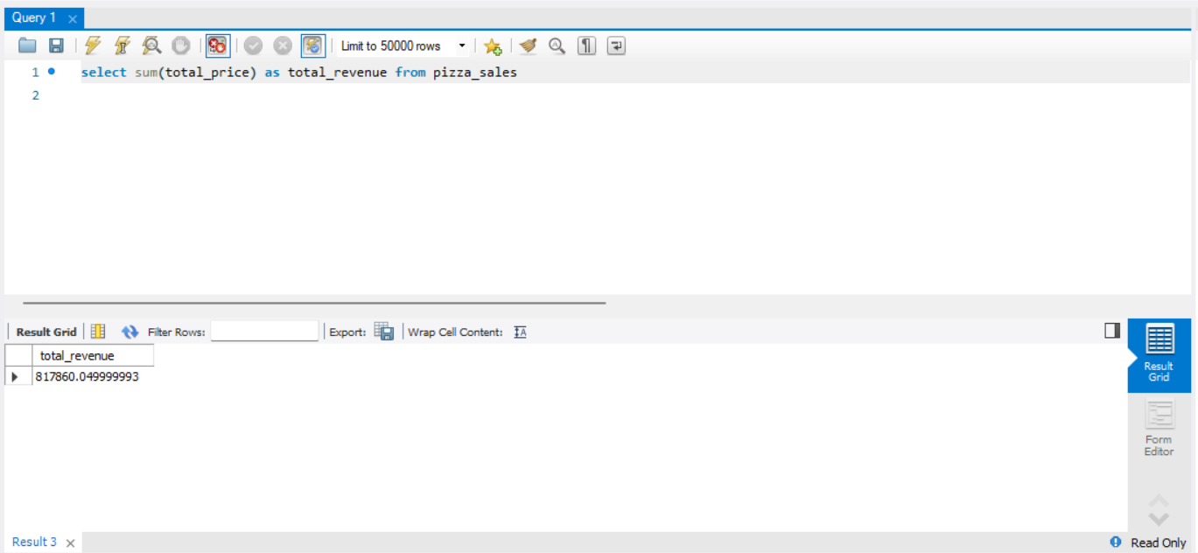

**2. Average Order Value**

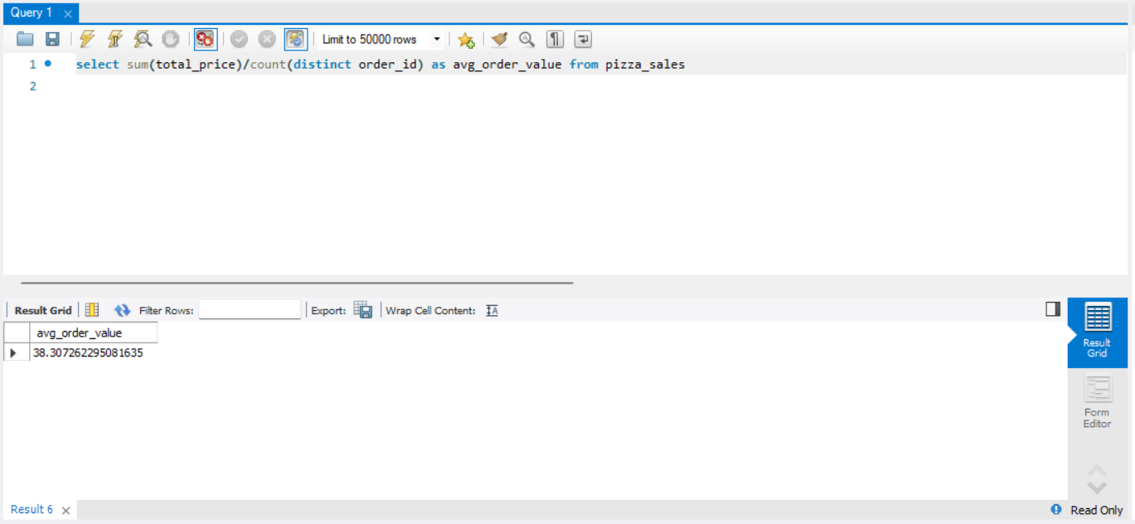

**3. Total Pizzas Sold**

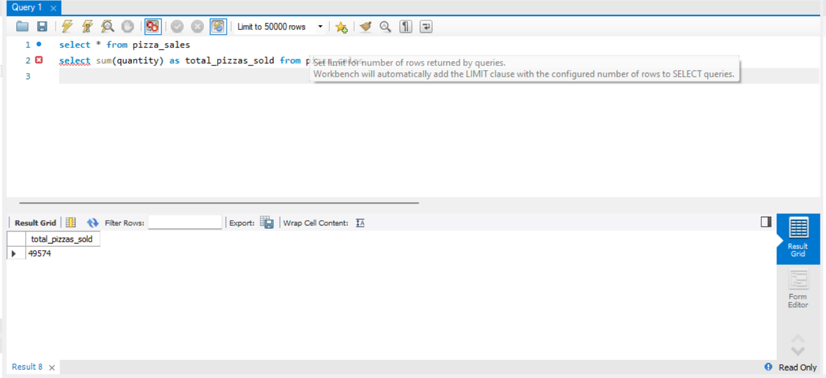

**4. Total Orders**

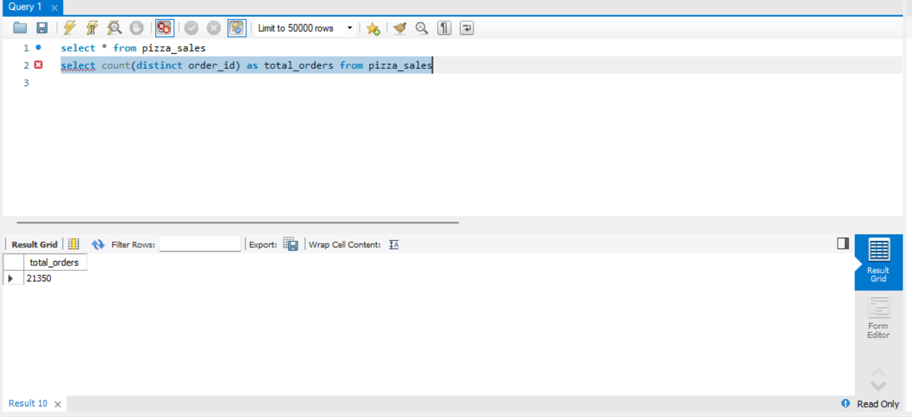

**5. Average Pizzas Per Order**

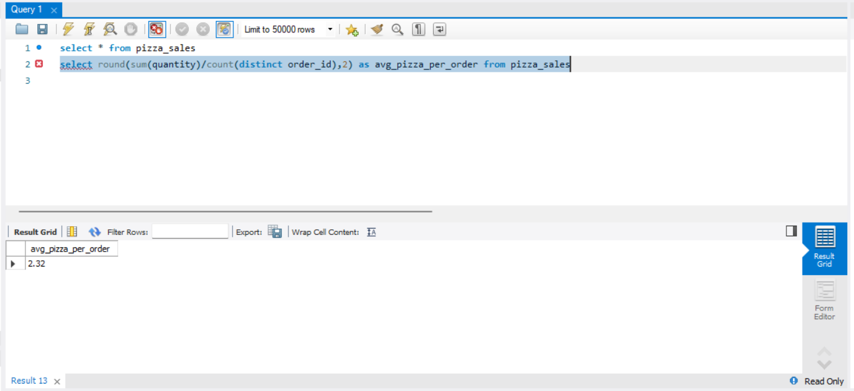

**B. Daily Trend for Total Orders**SELECT DATENAME(DW, order_date) AS order_day, COUNT(DISTINCT order_id) AS total_orders

FROM pizza_sales

GROUP BY DATENAME(DW, order_date)

***Output:***

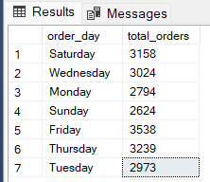

**C. Monthly Trend for Orders**

select DATENAME(MONTH, order_date) as Month_Name, COUNT(DISTINCT order_id) as Total_Orders

from pizza_sales

GROUP BY DATENAME(MONTH, order_date)***Output***

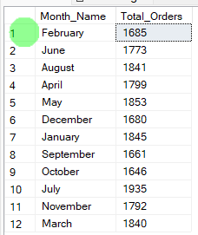

**D. % of Sales by Pizza Category**

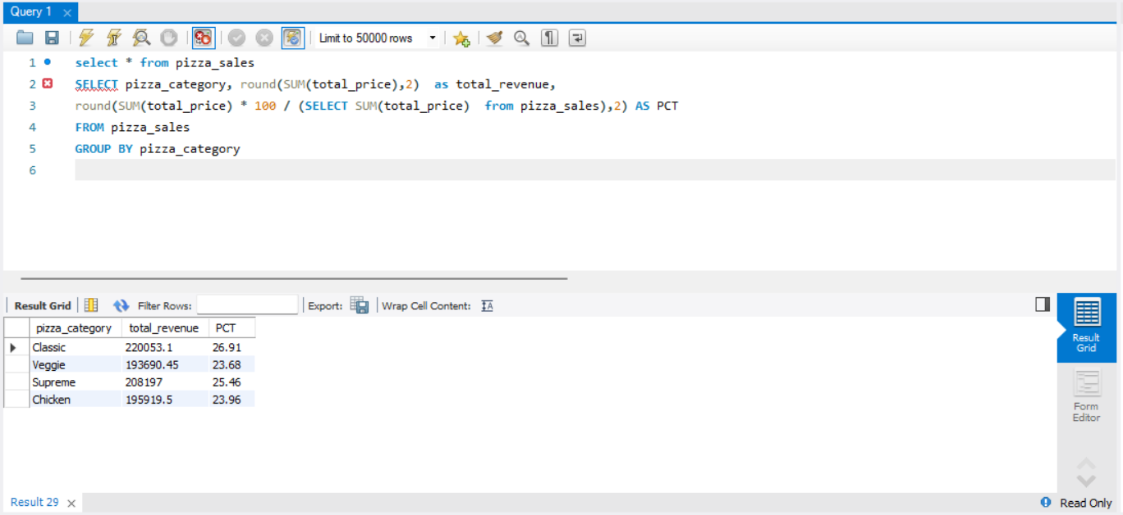

**E. % of Sales by Pizza Size**

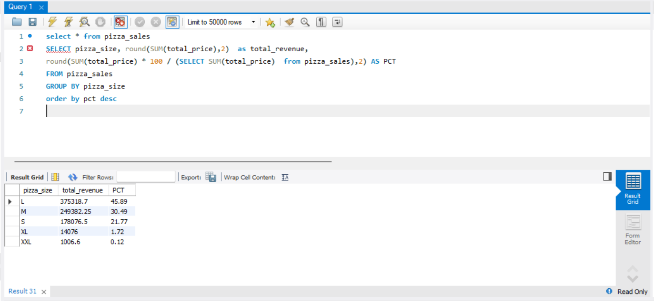

**F. Total Pizzas Sold by Pizza Category**

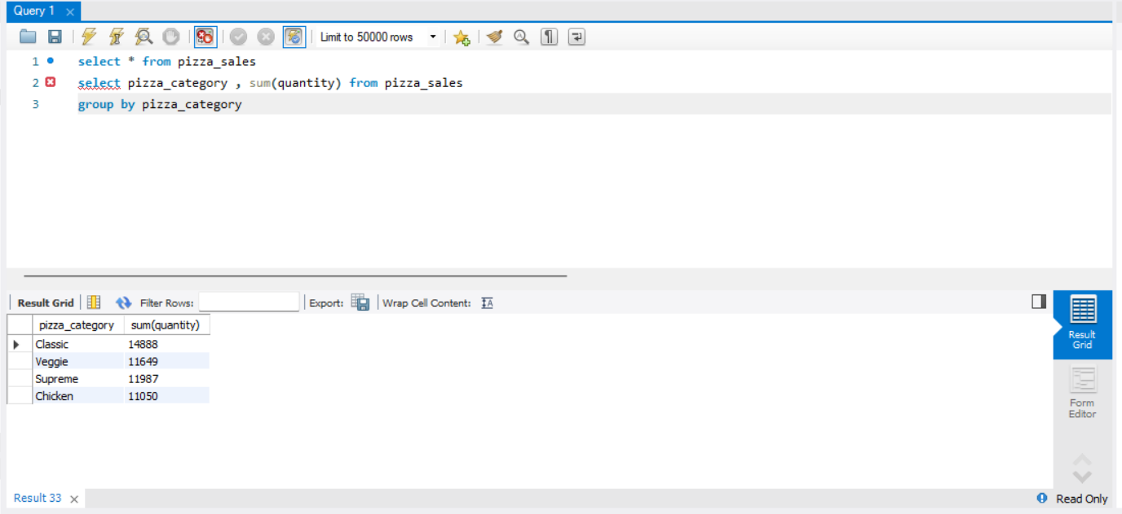

**G. Top 5 Pizzas by Revenue**

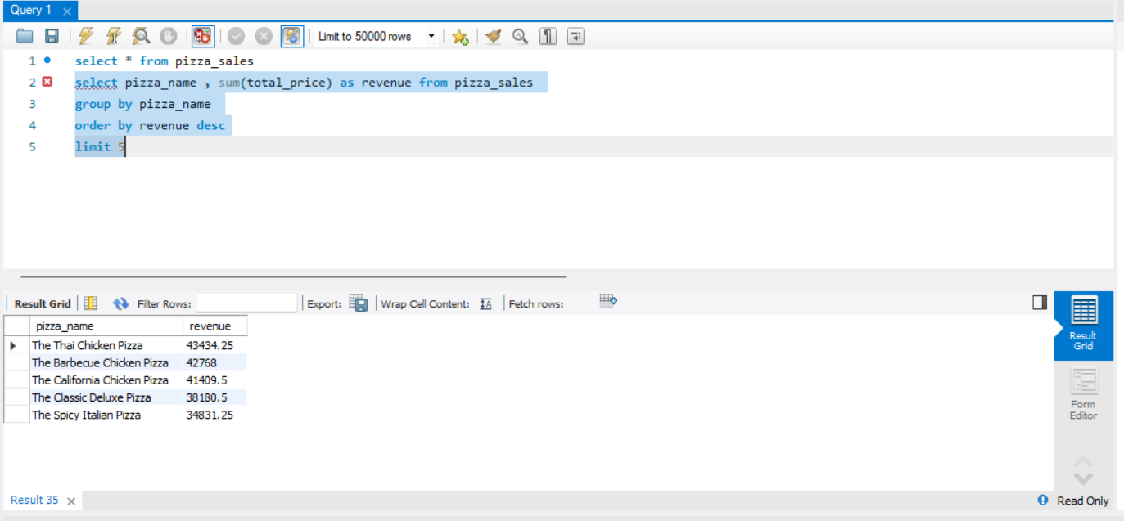

**H. Bottom 5 Pizzas by Revenue**

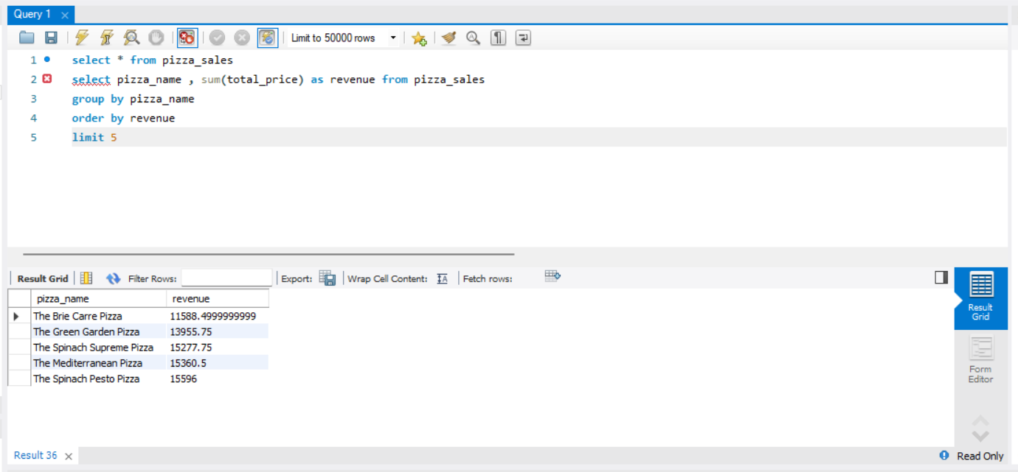

**I. Top 5 Pizzas by Quantity**

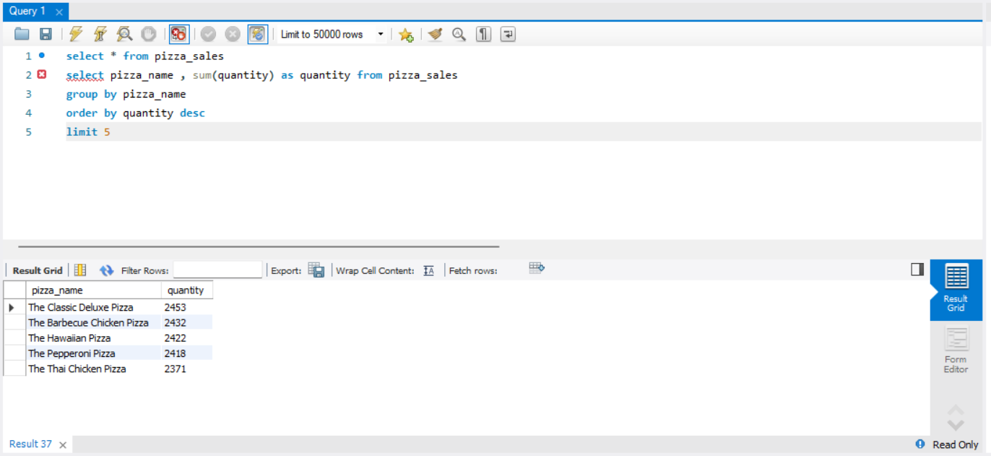

**J. Bottom 5 Pizzas by Quantity**

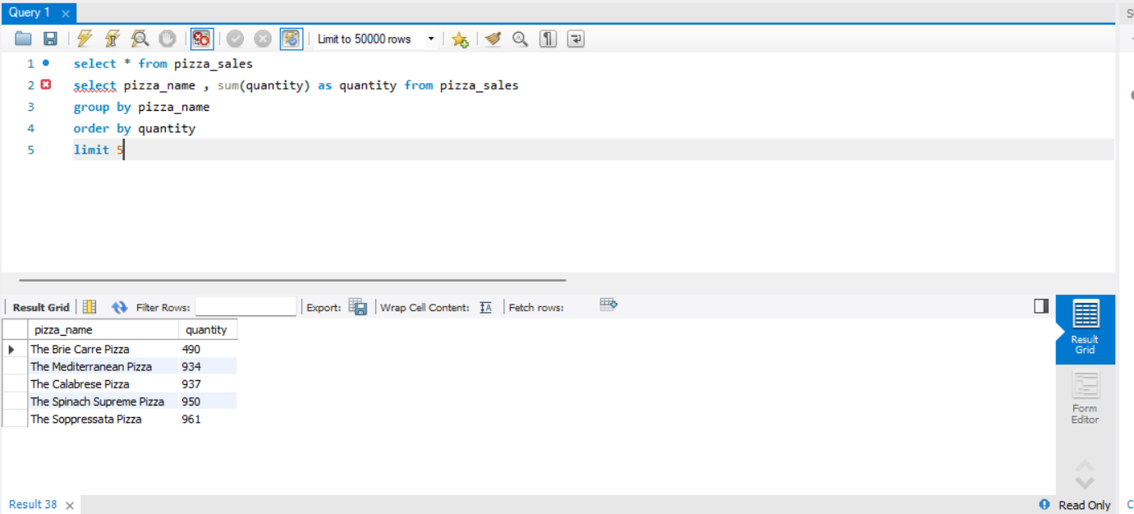

**K. Top 5 Pizzas by Total Orders**

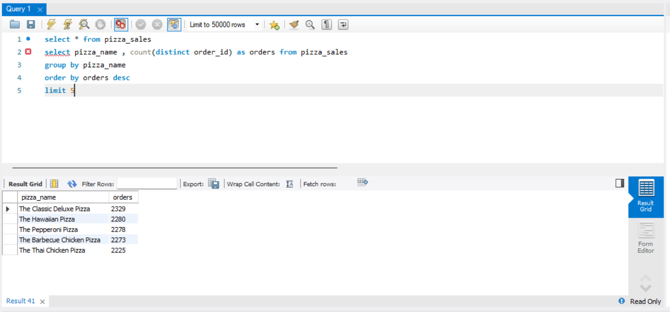

**L. Bottom 5 Pizzas by Total Orders**

